

**MSc Advanced Computer Science**

**Research methods and Project Management – CMP7158**

**Assignment 2**

**Project Management Report on**

**The New Terminal at**

**London Heathrow Airport**

**Date of submission: May 27, 2021**

**Table of Figures**

Figure 1: PRINCE2 Structure showing its themes which are guided by its principles (AXELOS, 2017). 5

Figure 2: Agile Process showing the iteration needed to complete a project (Baschin, et al., 2020) 8

Figure 3: PMBOK Process indicating the 5 stages of handling projects (Chaves, et al., 2016) 10

Figure 4: Heathrow Airport Proposal (Forgo, et al., 2009). Indicates the suggested changes in improving its chances of success. 13

Figure 5: Resource Management Process Indicating Possible ways to make most of resources (Abrantes & Figueiredo, 2015). 15

**Table of Tables**

Table 1: Risk Register for the System 16

Table 2: Product Backlog for the Terminal 6 Baggage System 17

Table 3: RACI Matrix for the Terminal 6 Baggage System 18

**Table of Contents**

1.0 Introduction 5

2.0 Methodologies 6

2.1 PRINCE2 Methodology 6

2.1.1 The Principles of PRINCE2 7

2.1.2 Themes of PRINCE2 7

2.1.3 Processes 8

2.2 AGILE Methodology 8

2.2.1 Principles 9

2.2.2 Process 10

2.3 PMBOK Methodology 11

2.3.1 Knowledge Areas 11

2.3.2 PMBOK Process 12

3.0 Methodology Selected 13

3.1 Advantages 13

3.2 Disadvantages 13

4.0 Applying a Technique 14

4.1 Computerized Baggage Handling System 14

4.2 Resource Management 15

4.3 Planning 16

4.3.1 Capacity 16

4.3.2 Allocation of Staff 17

4.3.3 Work Management 17

4.3.4 Team Management 17

4.3.5 Individual-Resource Management 17

4.3.6 Risk Management 18

4.4 Product Backlog 19

4.5 RACI Matrix 20

5.0 References 21

# 1.0 Introduction

Project management is an important process involved in planning resources, time, budget, and processes that take a project to its end (Bondarenko, et al., 2018). The procedure always needs careful consideration to catch all errors and risks, which need mitigation plans should they happen (Mhetre, et al., 2016). The Heathrow Airport project on Terminal 5 indicates an example of the possible ways a planned project could go wrong and what needs consideration in future large projects (Davies, et al., 2016). Looking at different ways of handling project management will allow an in-depth view into the mistakes that happened at Terminal 5 and possible solutions for the new Terminal 6.

# 2.0 Methodologies

## 2.1 PRINCE2 Methodology

The Projects in Controlled Environments (PRINCE2) manages projects that include the division and handling of projects into smaller sections (Jamali & Oveisi, 2016). The method handles projects in different areas of themes and principles, which define what to handle and in which order.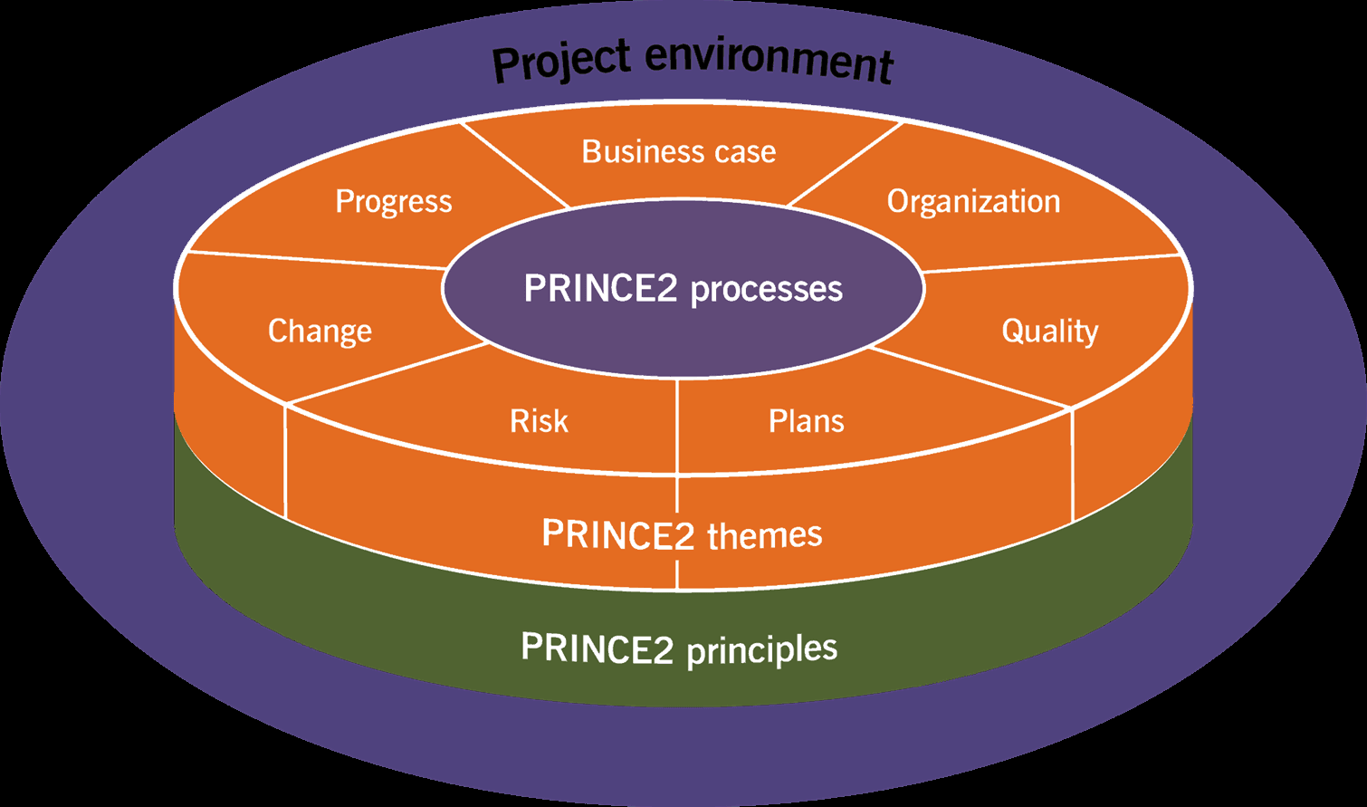

Figure : PRINCE2 Structure showing its themes which are guided by its principles (AXELOS, 2017).

### 2.1.1 The Principles of PRINCE2

* **Justification of business**: The business case should match the project and have enough meaning to take it through to the end.
* **Learning from experience:** The methodology requires the detailed keeping of records which helps teach the teams and participants how best to do their future tasks.
* **Clear definition of the responsibilities and roles of everyone**: Avoids confusion on the actions intended to be taken by particular individuals.
* **Managing the project in stages:** Allows the segmentation of the project into different stages for better management.
* **Management by exception:** Different levels of handling the management of the project, with varying exceptions in case of issues happening.
* **Focusing on the products**: The product quality and nature are key parts of projects, as they define their success or failure.
* **Changing to suit the project's nature**: The method is built to change and fit different environments as defined by the project.

### 2.1.2 Themes of PRINCE2

* **Business case** - Helps define whether the project fits the purpose and helps determine if desired results can be established.
* **Organization -** The organization helps define how the project will be structured and who will perform what action.
* **Quality** - Quality is essential in pushing for the best possible outcome and processes.
* **Plans** - Plans cover how the project will be controlled and handled in creating the product.
* **Risks** - This theme defines the possible failure points in the project and helps plan for possible ways to handle them.
* **Change** - Controlling the changes in the project is an essential part of the process, and the proper mechanisms to handle it should be set.
* **Progress** - Helps in keeping track of the changes and goals accomplished regarding the original plans.

### 2.1.3 Processes

The list of processes in PRINCE2 covers the starting of the project, initial stages, directing of the project, controlling of the stages, management of delivery processes of the product, keeping of set boundaries as per the stages, and final closing of the project (Naik & Jenkins, 2019).

## 2.2 AGILE Methodology

This is a methodology that covers projects in a collaborative team environment with constant development and testing (Srivastava, et al., 2017). Agile is commonly applied in software projects, but the core principles are applicable in any project. The process comes in handy when the delivery process needs to happen in small sections, with integrated feedback and room for fixing identified issues (Patwardhan, et al., 2016). The time period between creating components and experiencing how it is received is also reduced, with the promise of a higher quality of awareness. Teams interact throughout the process using special tools and processes. Further, agile also calls for detailed documentation of the actions, crucial for fixing issues. Collaboration with the product user is also encouraged, as it gives an excellent understanding of the progress (Senabre Hidalgo, 2018). A final response to changes throughout the project is a core value of agile and defines its nature.

### 2.2.1 Principles

* Teams and individuals need to work together.
* Individuals and teams need to support each other if need be
* Extensive communication is encouraged
* The process needs to be as simple as possible
* The process needs to be ready for change
* Customer satisfaction is crucial
* Use of excellent tools in the process
* Frequent delivery of updates
* The process needs to be sustainable
* Attention should be constantly paid to the process
* Feedback and adjusting to issues are crucial

### 2.2.2 Process

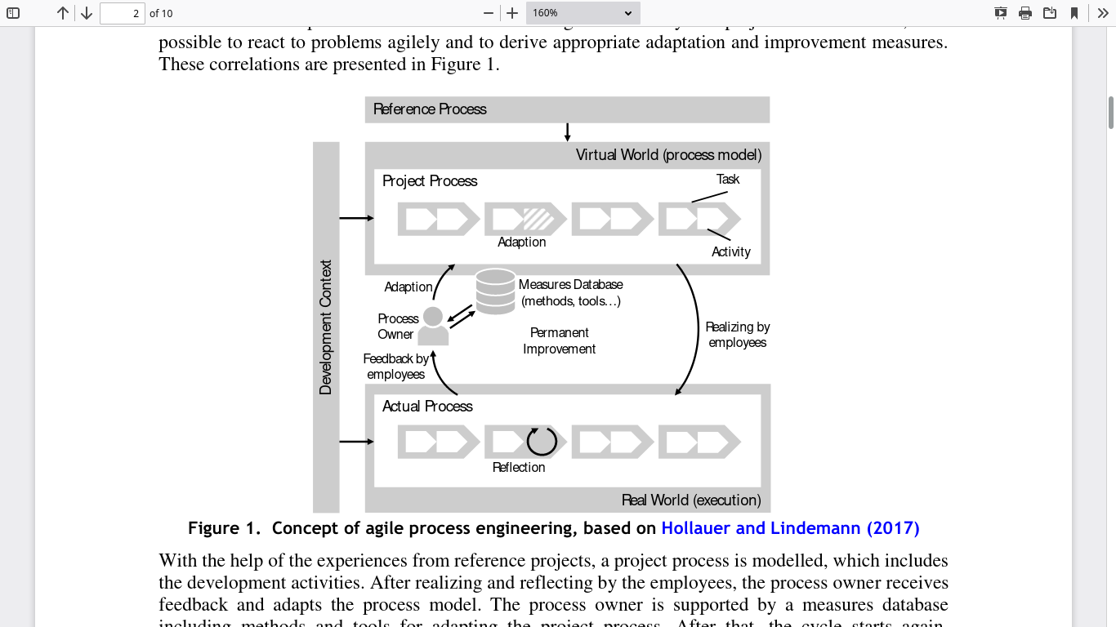

Figure : Agile Process showing the iteration needed to complete a project (Baschin, et al., 2020)

**Requirement definition** - Provided in a discussion between the customer and the development team.

**Design** - Covers the creation of ideas and theoretical representation of the product.

**Development** - Involves the creation of a version of the product as per the design.

**Testing the product** - Runs a suite of tests that check whether the product functions as intended.

**Deploying the product** - Pushes the project to the customer for real-world testing, use, and feedback.

**Reviewing and Monitoring of feedback** - Handles the issues raised by the customer, which then circle to the process.

## 2.3 PMBOK Methodology

The Project Management Body of Knowledge (PMBOK) includes a collection of definitions and guidelines for managing project processes (Jamali & Oveisi, 2016). This methodology defines an approach of disciplines one can take to set goals through specific skills and tools.

### 2.3.1 Knowledge Areas

**Integration Management** - Contains the processes that involve the project and how they relate to the general intention (Demirkesen & Ozorhon, 2017).

**Scope Management** - Covers the work which entails the project and how to accomplish it.

**Schedule Management** - Managing the time limits of the project, such as planning, allocation, and monitoring.

**Cost Management** - Keeps a close eye on the budget required to complete the project and the necessary estimates to complete each task.

**Quality Management** - The handling of the product quality, which should be as high as possible with provided resources and time.

**Resource management** - The area deals with allocating the items necessary to complete the project, such as tools and teams.

**Communication Management** - The better the communication, the easier it is to handle issues in a project successfully.

**Risk Management** - Risks faced by each project need to be carefully considered with the necessary mitigation plans.

### 2.3.2 PMBOK Process

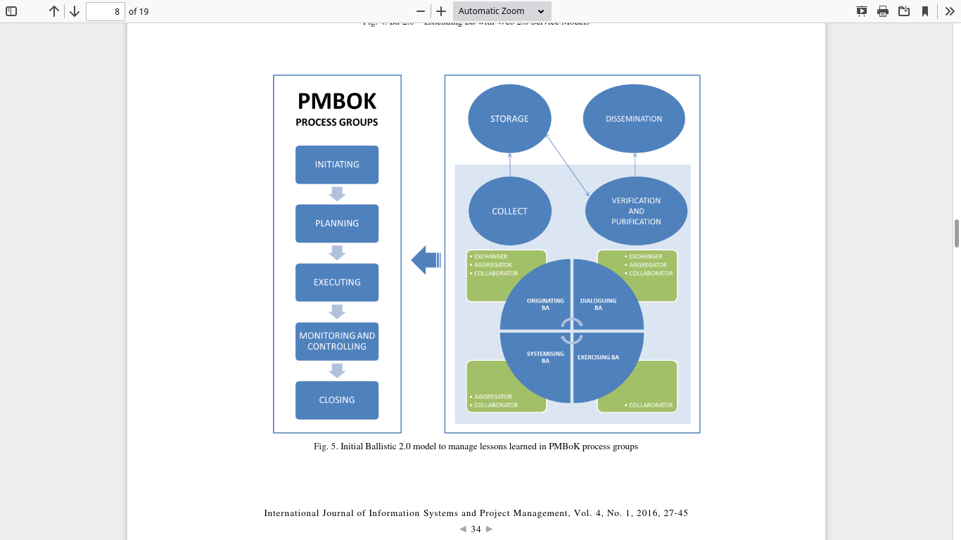

Figure : PMBOK Process indicating the 5 stages of handling projects (Chaves, et al., 2016)

**Initiating the Project** - The starting area that helps define the intention of the project and its overview. The project charter is a crucial document created at this stage.

**Planning** - This stage covers the definition of how the team will handle different management roles, scope, and scheduling of processes.

**Executing the plan** - Executing follows the defined plan through the project with additional management of its associated knowledge.

**Monitoring and Control of the Project** - Control is important in pushing the project to its end, with details on progress kept for further analysis.

**Closing the project** - This is the last stage covering the ending of the project and the possible handover of the product.

# 3.0 Methodology Selected

Each of these methodologies has a different approach to handling projects. The best choice for terminal 6 is the PMBOK. This decision comes after looking at the upsides and downsides of each process, with AGILE being too demanding for such a large and complex project. Further, the PRINCE2 method might be costly and complex for the case study.

## 3.1 Advantages

1. Fit for large projects.
2. Covers detailed communication, risk, and efficient handling of goals.
3. PMBOK enjoys a wide coverage of experts.
4. The methodology is frequently updated to cover new areas.
5. The process is crucial when standardizing processes and practices.

## 3.2 Disadvantages

1. Introduction of extra complexity to a large project.
2. No flexibility in creativity among the teams
3. Unnecessary communication
4. Increased running costs.

# Applying a Technique

## 4.1 Computerized Baggage Handling System

The computerized Baggage Handling system provides a key role to the airport. Luggage handling works by handling passenger luggage through the buildings and terminals and ferry them to the correct areas (Cavada, et al., 2017). The systems need to automatically determine where the passenger is going or coming from and directing their bag to the correct area. This chosen process was a major setback for the terminal 5, which called for improvement in terminal 6. By improving the baggage handling, the major part of the terminal activities is thereby covered.

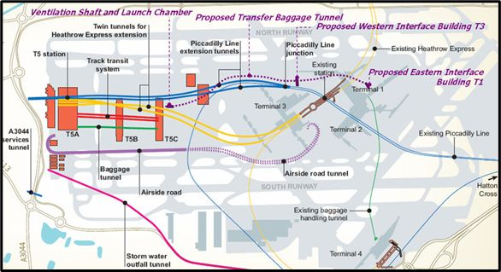

Figure : Heathrow Airport Proposal (Forgo, et al., 2009). Indicates the suggested changes in improving its chances of success.

## 4.2 Resource Management

Resource management in the PMBOK methodology is essential to handle how resources are applied (Armenia, et al., 2019). Resource management in the baggage handling system entails controlling the loading of luggage, enough computing resources for the automated processes, and quick offloading of bags also need strict supervision to prevent clogging of the system.

The management at terminal 6 needs to understand the resource management process for applying the technique to work. Planning for the process needs the inclusion of all participants, including managers and every staff working in the area. The PMBOK calls for extensive communication between different parties (Invernizzi, et al., 2018). This exchange needs to start early in the project, and key actions should consider the opinions of all affected people. The loading and unloading crew are a key part of baggage handling, as delays at these points produce bottlenecks limiting the process.

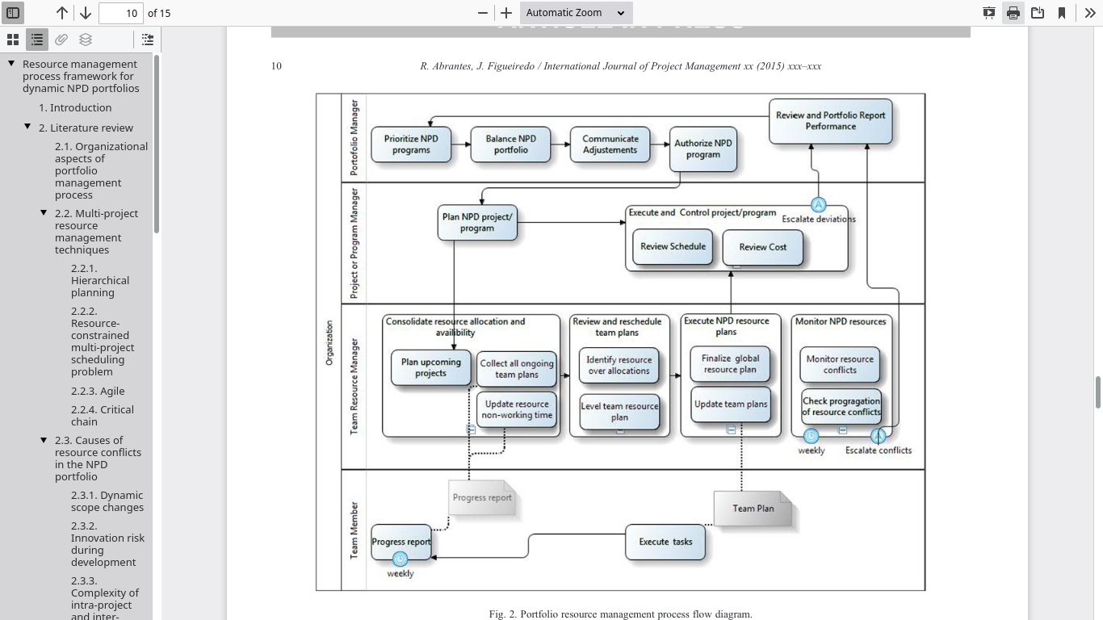

Figure : Resource Management Process Indicating Possible ways to make most of resources (Abrantes & Figueiredo, 2015).

## 4.3 Planning

### 4.3.1 Capacity

The capacity of the baggage system is crucial for estimating how well terminal 6 can perform. The process should cover the roles of each person and how much of their work they can handle. Bottlenecks should be identified and noted. The airport should also consider a general oversupply or undersupply of extra staff should they be needed.

### 4.3.2 Allocation of Staff

The resources allocated for each staff in the baggage process are also important. The staff should be assigned according to skills, how available they are, and their best performance environment. The management should then allocate the resources and staff with the consideration of luggage flow.

### 4.3.3 Work Management

The assignment of tasks from the management viewpoint should also be efficient. The airport needs to reduce any possibility of slow allocation of roles with a competent workforce. Monitoring the performance of the staff is also a good indicator of the overall progress of the system.

### 4.3.4 Team Management

If collaboration is needed, the airport needs to simulate and understand how well to carry out such. Teams improve the overall work, but at times might be a hindrance to efficiency. The communication styles of the teams also need to be excellent to reduce possible issues.

### 4.3.5 Individual-Resource Management

Encouragement from management team is an important part of every organization, providing reasons for staff to be as resourceful as possible (Yuniarsih & Sugiharto, 2016). The motivation might come in the form of rewards and support of individual workers. By providing the correct knowledge, additional support can help prevent the issues raised in terminal 5.

### 4.3.6 Risk Management

**Legend**

Impact Score: 1=Insignificant, 2=Minor, 3=Moderate, 4=Major, 5=Severe

Likelihood Score: 1=Unlikely, 2=Possible, 3=Likely, 4=Almost Certain, 5=Certain

|  |  |  |  |  |
| --- | --- | --- | --- | --- |
| **Risk** | **Description** | **Response** | **Impact**  **Score** | **Likelihood**  **Score** |
| Excess luggage | Excess luggage can cause the system to slow down or possibly to stop. | Stress test the system to understand its limits and defer extra customers to other terminals during peak times. | 5 | 4 |
| Unavailable staff | Insufficient staff when there is a surge in luggage as more customers check-in. | Hire more staff to cater for a possible overload of services. | 3 | 3 |
| Inefficient staff training | The complex system needs time to train the staff sufficiently. Hurried training can introduce issues when staff does not fully understand their roles. | Delay launch if the staff is not trained enough to confidently handle the roles and increase their training. | 4 | 2 |
| System failure | Hardware or software failure causing a stop in the luggage handling process. | Have backup systems to take over in case of a failure. | 5 | 5 |
| Luggage damages | Possible damaged luggage is a common risk in any baggage handling system. | Extra staff training on careful handling of the luggage. | 3 | 4 |

Table : Risk Register for the System

## 4.4 Product Backlog

Keeping a product backlog is crucial for keeping track of the needs that the system might need (Dalton, 2019). All actions that can be used to improve or apply in the baggage system need to be recorded. The product backlog will list the item name, priority, and an explanation. The template below will represent the backlog the project needs to build.

|  |  |  |
| --- | --- | --- |
| **Item** | **Priority** | **Description** |
| Test suite | High | Run automated tests on the functionality of the system to ensure it covers the requirements. |
| Piloting | Medium | Run the system in a real-world scenario to testify whether it is working. |
| Cloud backup tool | High | Have automated backups in case the system fails, corrupts data, and needs restoring. |
| Overload sensors | Medium | Test the sensors to detect when the baggage handling is getting out of hand for the staff to handle. |
| Stress testing the system | High | Test the system against limited resources and overload of luggage to ascertain its limits. |
| Staff training | High | Train the staff on the proper interaction with the system. |
| User Experience Feedback | Medium | Obtain feedback from the users interacting with the baggage system as early as possible to identify issues. |

Table : Product Backlog for the Terminal 6 Baggage System

## 4.5 RACI Matrix

A RACI matrix is crucial for outlining the assigned responsibilities for different participants in a project (AlFaki, et al., 2016). The matrix is usually presented in a chart format, with activities and the participants listed to show who is responsible for each activity and at what level. The matrix below shows the RACI matrix for the terminal 6 baggage system.

**Legend**

R = Responsible person for handling the activity

A = Accountable person for making major decisions on the activity.

C = Consultable person who will be communicated on information about the activity.

I = Informed person who will receive minor communication on the activity.

|  |  |  |  |  |  |
| --- | --- | --- | --- | --- | --- |
| **Activities** | **Project Manager** | **Software Development Team** | **Building Department** | **Testing Team** | **Integration Team** |
| Initiate the project | R | A | A | I | I |
| Integrate the System to airport | A | A | C | C | R |
| Test the baggage system | A | A | I | R | I |
| Monitor System | R | A | I | C | I |

Table : RACI Matrix for the Terminal 6 Baggage System

# 5.0 References

* 1. Abrantes, R. & Figueiredo, J., 2015. Resource management process framework for dynamic NPD portfolios. *International Journal of Project Management,* 33(6), pp. 1274-1288.
  2. AlFaki, M. A., Ali, O., Babiker, A. E. & Ibrahim, A. O., 2016. Agile RACI Model for Extreme Programming Method. *International Journal,* 6(5).
  3. Armenia, S., Dangelico, R. M., Nonino, F. & Pompei, A., 2019. Sustainable project management: A conceptualization-oriented review and a framework proposal for future studies. *Sustainability,* 11(9), p. 2664.
  4. AXELOS, 2017. *Managing Successful Projects with PRINCE2.* 6 ed. s.l.:s.n.
  5. Baschin, J., Huth, T. & Vietor, T., 2020. *Context-specific agile process design to support the planning of product development projects. In Proceedings of the Design Society: DESIGN Conference.* s.l., Cambridge University Press, pp. 491-500.
  6. Bondarenko, S., Lagodienko, V., Sedikova, I. & Kalaman, O., 2018. Application of project analysis software in project management in the pre-investment phase. *Journal of Mechanical Engineering and Technology,* 9(13), pp. 676-684.
  7. Cavada, J. P., Cortés, C. E. & Rey, P. A., 2017. A simulation approach to modelling baggage handling systems at an international airport. *Simulation Modelling Practice and Theory,* Volume 75, pp. 146-164.
  8. Chaves, M. S. et al., 2016. A new approach to managing lessons learned in the PMBoK process groups: the Ballistic 2.0 Model. *International Journal of Information Systems and Project Management (IJISPM).*
  9. Dalton, J., 2019. *Product Backlogs. In Great Big Agile.* Berkeley, CA, Apress, pp. 205-207.
  10. Davies, A., Dodgson, M. & Gann, D., 2016. Dynamic capabilities in complex projects: The case of London Heathrow Terminal 5. *Project management journal,* 47(2), pp. 26-46.
  11. Demirkesen, S. & Ozorhon, B., 2017. Impact of integration management on construction project management performance. *International Journal of Project Management,* 35(8), pp. 1639-1654.
  12. Forgo, L., Megyeri, T. & O’Donoghue, B., 2009. A case study in advanced numerical modelling in design: Heathrow Airport Transfer Baggage Tunnel, UK..
  13. Invernizzi, D. C., Locatelli, G. & Brookes, N. J., 2018. The need to improve communication about scope changes: frustration as an indicator of operational inefficiencies. *Production Planning & Control,* 29(9), pp. 729-742.
  14. Jamali, G. & Oveisi, M., 2016. A study on project management based on PMBOK and PRINCE2. *Modern Applied Science,* 10(6), pp. 142-146.
  15. Mhetre, K., Konnur, B. A. & Landage, A. B., 2016. Risk management in construction industry. *Int. J. Eng. Res,* 5(1), pp. 153-155.
  16. Naik, N. & Jenkins, P., 2019. *A Web Based Method for Managing PRINCE2® Projects Using Trello®.* s.l., IEEE, pp. 1-3.
  17. Patwardhan, A., Kidd, J., Urena, T. & Rajgopalan, A., 2016. Embracing Agile methodology during DevOps Developer Internship Program. *arXiv preprint arXiv:1607.01893.*
  18. Senabre Hidalgo, E., 2018. Management of a Multidisciplinary Research Project: A Case Study on Adopting Agile Methods. *Journal of Research Practice,* 14(1), p. 1.
  19. Srivastava, A., Bhardwaj, S. & Saraswat, S., 2017. *SCRUM model for agile methodology.* s.l., IEEE, pp. 864-869.
  20. Yuniarsih, T. & Sugiharto, M., 2016. Human resource management model to create superior performance. *International Journal of Education,* 9(1), pp. 75-81.

**Peer Evaluation Forms**

Evaluator’s Name: Manpreet Kaur

Date: 25/05/21

**Group Member 1/Student ID: Hafsa Zulfqar 20162029**

1. Did this group member complete his/her assigned tasks for the group? Yes No

2. How would you rate the quality of this person’s work? 1 2 3

3. How would you rate the timeliness of the completion of the work? 1 2 3

4. How would you rate the accuracy of the work? 1 2 3

5. Overall, how would you rank this group member’s performance in the group? 1 2 3

6. Would you want to work with this person again? Yes No

**Explain why in the space below.**

Hafsa Zulfqar has a good attitude for debating which was helpful during the project, but as project manager she wasted our lots of time waiting for Ayaz so we postponed our meeting many time. Due to this we were unable to send our draft on time. Apart from this, her academic writing is good but she kept on using websites as a reference even after we decided to use only book and papers.

**Group Member 2/Student ID: Ayaz Khan 20171602**

1. Did this group member complete his/her assigned tasks for the group? Yes No

2. How would you rate the quality of this person’s work? 1 2 3

3. How would you rate the timeliness of the completion of the work? 1 2 3

4. How would you rate the accuracy of the work? 1 2 3

5. Overall, how would you rank this group member’s performance in the group? 1 2 3

6. Would you want to work with this person again? Yes No

**Explain why in the space below.**

Ayaz Khan was our team member but before start to work with us he left the group and we also try personally to call him but he did not replied at all. So we distributed our task in between rest team members and complete our assignment work. But we started our work late and did not submit our draft.(because we were waiting).

**Group Member 3/Student ID: Manisha Jaiswal (20159408)**

1. Did this group member complete his/her assigned tasks for the group? Yes No

2. How would you rate the quality of this person’s work? 1 2 3

3. How would you rate the timeliness of the completion of the work? 1 2 3

4. How would you rate the accuracy of the work? 1 2 3

5. Overall, how would you rank this group member’s performance in the group? 1 2 3

6. Would you want to work with this person again? Yes No

**Explain why in the space below.**

Manisha Jaiswal missed her few meetings and deadlines but her work was good and helpful for the group. She didn’t interact a lot during the meetings but tried her best.

**Group Member 4/Student ID: Chinky Verma 20161618**

1. Did this group member complete his/her assigned tasks for the group? Yes No

2. How would you rate the quality of this person’s work? 1 2 3

3. How would you rate the timeliness of the completion of the work? 1 2 3

4. How would you rate the accuracy of the work? 1 2 3

5. Overall, how would you rank this group member’s performance in the group? 1 2 3

6. Would you want to work with this person again? Yes No

**Explain why in the space below.**

Chinky attended all her meetings, discussed and participated actively in the meetings. Also her academic writing and critical understanding of the problem were really useful for the group.

**Group Member 5/Student ID: Faran Sohaib Cheema 2017701**

1. Did this group member complete his/her assigned tasks for the group? Yes No

2. How would you rate the quality of this person’s work? 1 2 3

3. How would you rate the timeliness of the completion of the work? 1 2 3

4. How would you rate the accuracy of the work? 1 2 3

5. Overall, how would you rank this group member’s performance in the group? 1 2 3

6. Would you want to work with this person again? Yes No

**Explain why in the space below.**

Farhan missed his few meetings, also either his academic writing is not good enough to deliver a good assignment so we need to do some changes he wrote. But has technical knowledge for understanding the main issues relating to our project.

**Self-reflection:**

**What is Self-reflection?**

Research shows that a combination of student provides motivation to learn and enjoy the process of learning.

**Explore the benefits of the group work?**

In Group work I develop stronger communication skills, also refine understanding through discussion and explanation.

Apart from this, break the complex tasks and distributed to every person and work become easy.

**Explore the challenges in the group?**

In first interaction Lack of trust was major challenges, as trust is crucial to teamwork, and it starts with team members knowing each other.

Conflict and tension is another challenge and Low engagement is also part of group work.

**Give examples of the benefits and challenges your group faced. Discuss how your group handled your challenges.**

Our communication skill has been improved while discussing various project topics. We worked together and had managed our time to overcome obstacles as we started our work late. From the very first day when we were grouped together, we were unable to contact one of the members though we wait for that person to join us on Whatsapp group, on call but unfortunately, he just left the group and had not responded to our calls. At last, we discussed and start the work without wasting any more time. Secondly, it was critical for us to manage the time all at same time according to everyone’s availability. Finally, we fixed a time like a mandatory class to be attended to accomplish the task before time. **A**lso confused first which methodology is good but latter on we decided as well as make it plagiarism free because everyone taking information that actually somewhere in the database so to rephrase every single word was also challenged for us.

**Discuss what you will do differently next time.**

Hopefully, next time due to our past experienced, we will take action quickly if someone will not response. Focus on our work on time.